Design and Simulation of a Wide-Band OTA for Neural Network Application

Mohammad Chahardori
ID:11632753

Abstract—In this paper, the design procedure and simulation result of a fully differential input and single ended output OTA in 130nm CMOS technology has been presented. The designed amplifier is used as a high gain comparator in a read-out circuit to detect the biomed signals generated by neurons. The design OTA shows more than 60dB gain in low frequency and 52-degree phase margin with 800 MHz bandwidth when it is connected to 1 PF load capacitance. The presented OTA consumes less than 2 mA current from 1.3V supply voltage. The performance of the design structure has been proved using cadence spectre simulation tools.
Keywords—OTA; biomed amplifier; high gain comparator

Introduction
Operational Transimpedance Amplifiers (OTAs) have been used widely as high gain blocks in CMOS technology where, most circuits usually drive just capacitive loads. Because of very high gain of two-stage OTAs they have been used in some application as a high gain comparator.
In this paper we present the required steps toward designing a conventional high gain OTA while we try to achieve the desired performance using the minimum power consumption. The arrangement of this paper is as follow:
In section II, the design of two-stage OTA is explained. In section III, the application of the designed OTA in a biomed structure is discussed. Section IV shows the simulation results and section V the achieved performance of the proposed circuit is summarized.

Design procedure of High Gain ota
This section has been dedicated to the design of the OTA. Among different parameters of an OTA, design methodology for acquiring the OTA gain, unity gain band width (UGBW), phase margin and slew rate have been covered in this section.

Amplifier Gain and frequency response
The schematic of the presented amplifier is shown in fig.1. the amplifier is a two-stage fully differential input and single ended output using low voltage high swing cascode current mirror in the first stage to increase the gain. In second stage a simple structure to achieve higher voltage swing has been used. The gain of the amplifier in low frequency is:
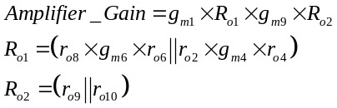 | (1)
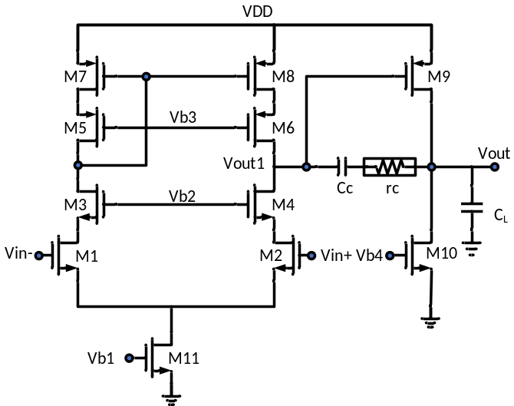
Fig.1. Schematic of the amplifier
The required amplifier gain is more than 60dB that is 1000. Since the intrinsic gain of each transistor (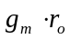) is about 10 to 20, we have allocated the gain of 100 to the first stage and gain of 10 to the second stage to achieve the overall gain of 1000. In that case we assume 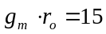 to compensate the effect of parallel resistor in (1). On the other hand, based on fig.1 the circuit would have two poles if we ignore the parasitic capacitors in the first step. Because of the gain in second stage we expect the miller effect increase the equivalent capacitor at the output of the first stage. This means that the dominant pole would be placed at the first stage output node and due to the pole-splitting effect the non-dominant pole at the amplifier output would be transferred to higher frequency. Consequently, we can derive the location of these two poles as:
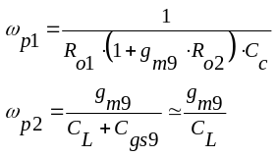 | (2)
On the other hand, based on the definition of UGBW for stable amplifier and from (1) and (2) we have:
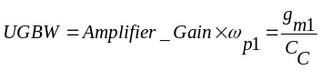 | (3)
This value should satisfy the UGBW of 800 MHz It should be mentioned that puts a limitation over overdrive voltages of transistors as follow:
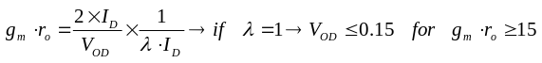 | (4)
From (4) we have to set the overdrive voltages of all transistor in signal paths that is M1 to M9 less than 150mV. In the proposed schematic, we can set the overdrive voltage of M1,2 and M9 on 100mV since the gm of these transistor have some direct effect on the frequency response and we have set the overdrive voltages of other transistor on 150mV to push the local non-dominant poles to higher frequency. However, because of limited headroom in first stage we need to consider even less than 100mV for current mirror transistors. So, except M1-M4 and M10-M11 which have overdrive voltage of 100mV and 150mV respectively, other PMOS transistors in current mirror has overdrive voltage of 50mV.
The other criteria that we need to achieve in this design is the phase margin (PM) of 52 degree. The phase margin of the proposed circuit considering a two poles behavior can be calculated from:
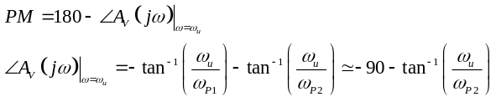 | (5)
In (5) we consider 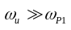 and as a result to achieve 52 degree PM we need to set 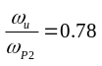, therefore 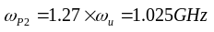. Now using (2) and based on the value of 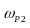 since CL=1PF we can calculate the value of gm9 and its bias current as well. We have:
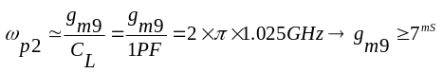 | (6)
In practice we should consider other parasitic capacitors in parallel to CL so we set the value of g_{m9} = 15mS which is twice the minimum value from (6) to make sure we would achieve the required PM. Now considering 100mV overdrive voltage for M9 we have:
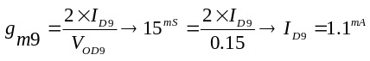 | (7)
By allocating around half of this DC bias current to M1 and M2, for example 0.5mA we can avoid of using large amount of power in the amplifier. In that case we have:
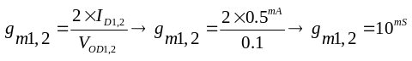 | (8)
Assuming the DC bias current for M1 and M2 gives us the DC bias current of other transistors. Now, we have the overdrive voltage of all transistors and the DC bias current of them, so we can calculate their W and L. Now we can calculate the value of Cc from (3) and (8) to have 800MHz of UGBW. The required Cc is about 2 PF. Table.I shows the technology parameters which we have used to calculate transistor sizing.

Table. I. Technology parameters
Parameter | Value
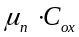 | 350 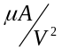
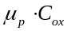 | 200
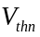 | 0.38 V
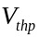 | 0.42 V
 | 0.5 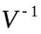
 | 0.45

In Table. II the values of W for each transistor which are calculated based on the equations (1) to (8) and the final values after simulating the circuit using cadence spectre are shown. The L for all transistors except M1, M2 and M11 is the minimum L.
Table. II. Transistor Sizing
Transistor Name | W_{Calculated} (µm) | W_{optimized} (µm)
M1 | 35 | 70
M2 | 35 | 70
M3 | 35 | 70
M4 | 35 | 70
M5 | 245 | 250
M6 | 245 | 250
M7 | 245 | 250
M8 | 245 | 250
M9 | 490 | 500
M10 | 30 | 55
M11 | 600 | 400
Now after deriving the values of overdrive voltage and size of transistor we can calculate the required bias voltage for the circuit. According to the fig.1 we have:
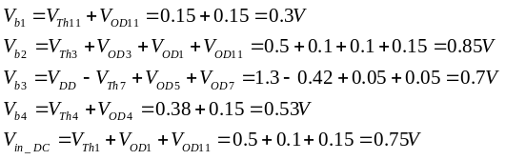 | (9)
The bias voltage values in final version of the proposed circuit have been implemented using diode connected transistor and ideal current sources. The value of implemented bias voltages are shown in Table. III. It should be mentioned that the value of 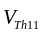has been considered about 150mV and W. This is due to the fact that the L of M11 is 20 times larger than Lmin and as a result W of M11 is 20 times larger than calculated W for Lmin which we will discuss it in section II.D.

Table. III. Bias voltages after circuit optimization
Bias Voltage Name | Voltage (mV)
Vb1 | 315
Vb2 | 1150
Vb3 | 700
Vb4 | 580
Vin | 700
As it is seen in the Table. II and Table. III, we have increased the value of Vb2 about 300mV. This voltage increase is for relaxing the input CM voltage range. This would be explained more in the section II.C

Slew Rate
The slew rate (S.R) of the amplifier is another constraint in design of the amplifier. The two-stage amplifier slew rate is mostly limited by the bias current and CL and Cc value in positive and negative output voltage variation [1_razavi book]. In the proposed structure since the values of 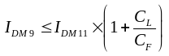 so the positive and negative slew rate are different and are achieved from:
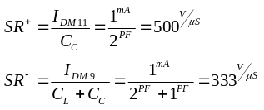 | (10)
Both positive and negative S.R of the designed circuit are better than required 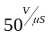which has been mentioned in the exam, as a result we don’t need to modify the circuit to satisfy the S.R criteria.

Input and output voltage swing
According to the fig.1 and the bias voltages and overdrive voltages achieved in section II.A we can estimate the input and output voltage range in which all transistors work on saturation region. The minimum input voltage has been limited by M11 when it goes to the triode region. Consequently, with DC input voltage of the 0.7V we can not reduce the input CM voltage more than 100mV. The maximum limitation for input CM voltage is when the M1,2 enters the triode region. In that case we have:

(11)
So, it is possible to change the input DC common mode voltage from 700mV to 1.1V which is about 400mV and conform the 0.3V required DC input common mode range.
The output swing in the proposed structure is mostly limited by the overdrive voltages of two transistors of the output stage that is, M9 and M10. The available output voltage swing is:
(12)

This voltage swing easily covers all the required range of voltage swing at the output.

CMRR due to transistor mismatches
Because of mismatch between technology parameter of the transistors in the proposed circuit, especially mismatch between M1 and M2, the fully differential amplifier doesn’t act exactly as expected and it amplify part of the common mode signal too. We can model this undesired effect by adding one voltage source at the amplifier input (we call it V_{offset}) and investigate the overall degradation due to that added voltage source. Typically, V_{offset} has a random value proportional to the size of input transistor. The variance of this random value can be achieved as bellow in 130nm CMOS:
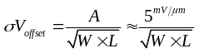 | (13)
On the other hand, the CMRR of the proposed amplifier without any mismatch can be calculated from
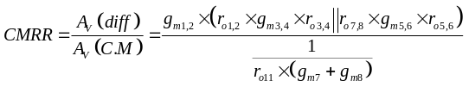 | (14)
As seen in (14) the CMRR is in order of 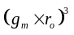which is close to 70dB in this technology with 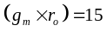 . It means that even without any mismatches in the circuit, it is really hard to achieve 80dB CMRR from the proposed circuit. We have two options here to reach the required CMRR. First, using a cascode current source and second, using very large size for the transistor of the current source. In the proposed structure we increase the L of M11 by a factor of 20 which would improve the CMRR with the same factor. The expected value of CMRR without mismatch after this modification in the M11 sizing is about 96dB. So, we can consider about 16dB reduction in CMRR due to the mismatches between input transistors while satisfying the 80dB overall CMRR. In fig.2 the amount of degradation in CMRR value due to the input offset voltage has been shown. We have used cadence simulator to achieve this curve by applying different offset voltage at the input and simulating CM gain at the output.
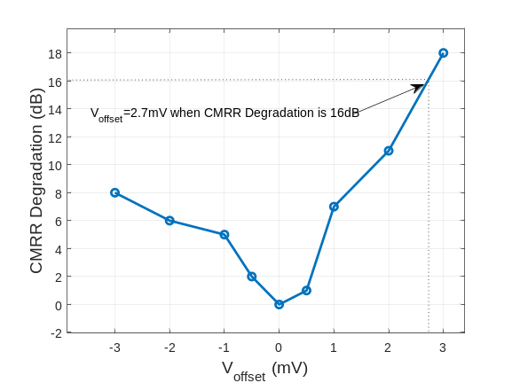
Fig.2. CMRR variation due to offset voltage at the amplifier input
Fig.2 shows that we can tolerate around 2.7mV offset voltage at the input to avoid more than 16dB permissible degradation on CMRR and satisfying 80dB overall CMRR. It means the maximum variance (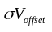) of the offset voltage can be 0.9mV. According to (13) to have 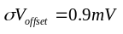 we should set the values of W and L in M1,2 such that 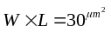. Based on the sizing of the M1,2 after circuit optimization in Table.1, we need 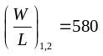. Consequently, 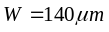 and 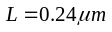satisfies both condition for W and L of M1, M2.

Neural Network application of the prpoposed OTA
To ascertain the performance of the proposed high gain amplifier, it has been used as a high gain comparator in the neuron electronic circuit modeling structure. In fig.3 the schematic of the whole circuit using a high gain amplifier as comparator is shown [2].
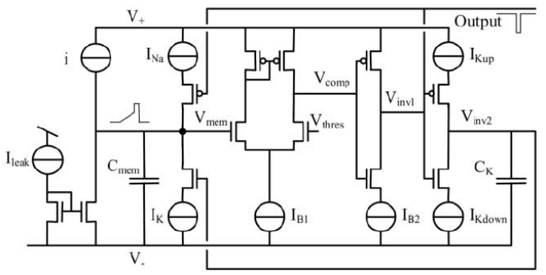
Fig.3. Models of neuron using a high gain amplifier as a comparator
In this circuit the value of C_{mem} and C_{K} alongside with current sources designate the delay and overall waveform. The values of the mentioned parameters have been calculated based on the equations in [2] to achieve the total duration of 1 us and 20 percent duty cycle at the output generated pulses. For transistors which acts as switch we consider high 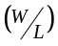 to reduce the on resistance. On the other hand, for the transistors which act as inverter we consider not much larger than minimum size. For the transistors which act as current mirror we calculated the size in a way that their overdrive voltage does not exceed 200 mV. The values of current sources and transistor sizing are shown in the final schematic in section. IV. To show the appropriate performance of the transient simulation of the circuit has been down and the required waveforms for V_{mem} and V_{output} have been achieved which are shown in the Section. IV.

Simulation Results
In this section the results achieved by simulating the behavior of the amplifier and the neural network circuit are presented separately.

OTA Simulation Result
To demonstrate that the proposed circuit satisfy all the requirements of the project, different sets of simulation have been done using Cadence spectre. In fig.4 the schematic of the proposed circuit in Cadence environment with the DC operating point of the transistors in the OTA structure has been shown. According to the fig.4, the overall current consumption is about 2.1mA which leads to 2.73mW power consumption.
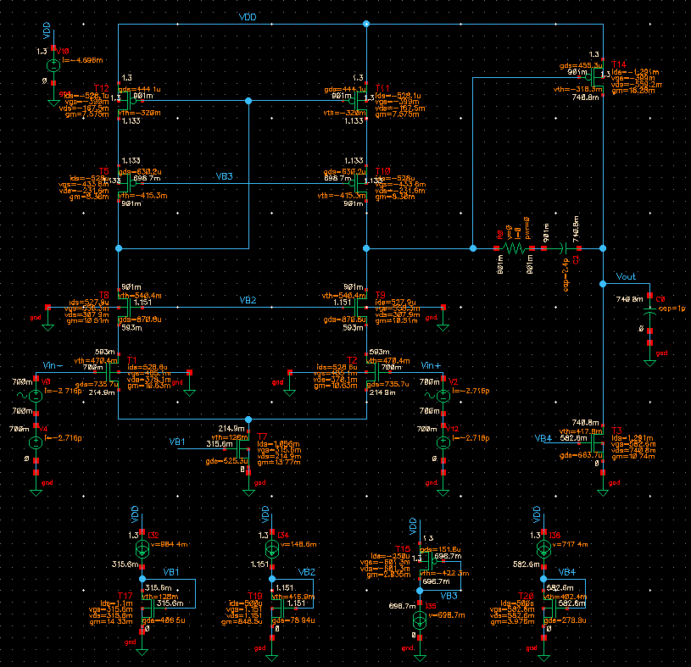
Fig.4. Schematic of the proposed OTA
To assure the stability of the circuit in unity feedback structure the open-loop gain and phase of the amplifier has been shown in fig.5. As it is seen in this figure the open-loop DC gain is around 66dB and the UGBW is 800 MHz. Also, the proposed circuit has PM better than 52 degree which satisfies the required frequency response of the amplifier.
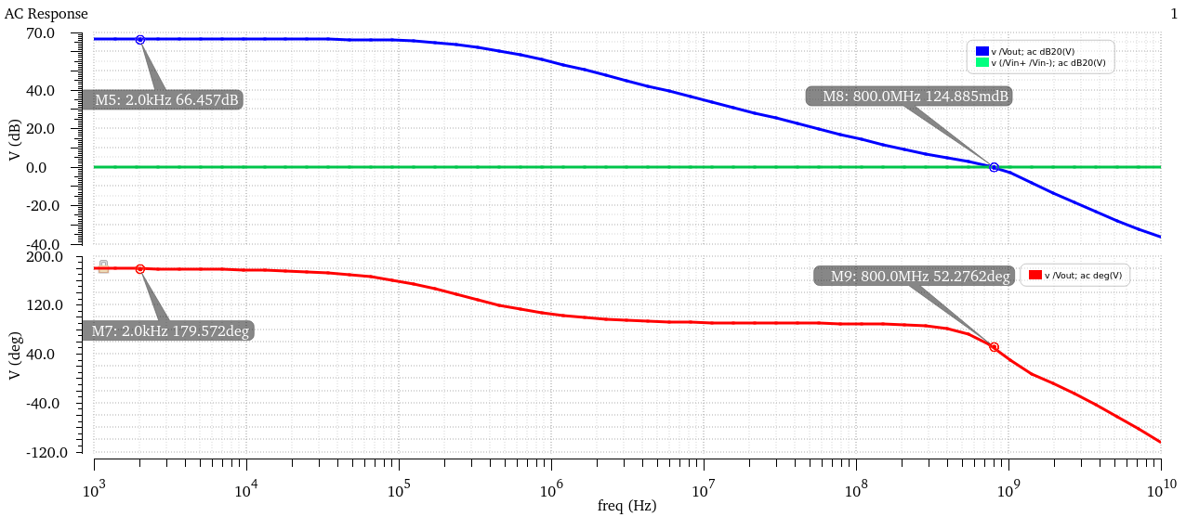
Fig.5. AC response of the proposed OTA
The other parameter which has been simulated here is the transient response. In fig.6 the input and output voltage of the amplifier when a small-signal low frequency sine input has been applied to the amplifier input has been drawn. According to fig.6 the output voltage swing is larger than 0.6 V as it is desired in the circuit.

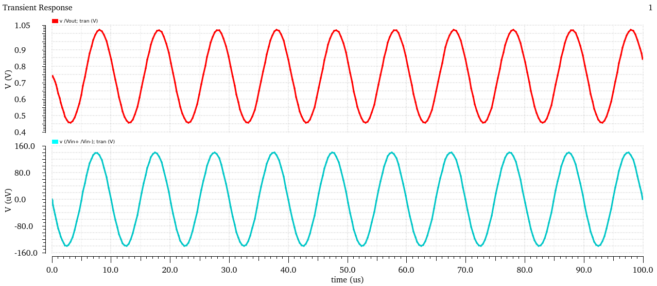
Fig.6. Transient response of the proposed OTA with high output swing
For the proposed amplifier it is also needed to tolerate more than 0.3V input common mode voltage variation. To demonstrate the operation of the proposed amplifier when it suffers input common voltage variation, the behavior of the amplifier in a closed loop structure with unity gain has been simulated and shown in fig.7.
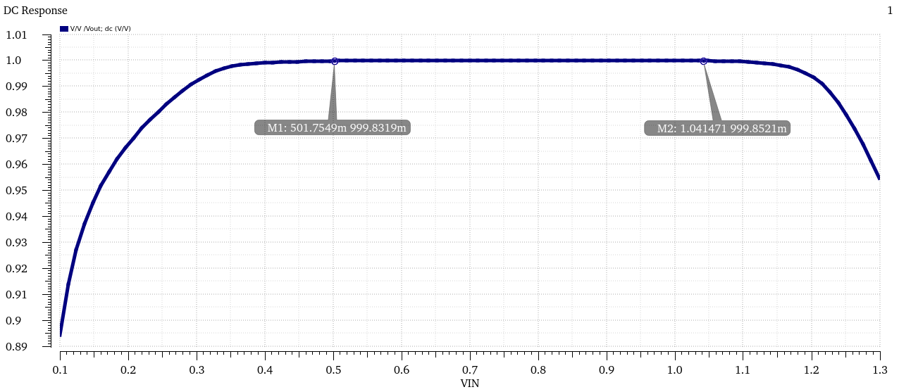
Fig.7. Common Mode range of input voltage
As it is clear in the fig.7, the output voltage follows the input voltage with no considerable error from 0.5V to 1.05V which indicates that all the transistors in the designed circuit including the input transistors are in the saturation region, so the unity gain of the amplifier is unchanged during this common mode voltage range.
The other important time domain parameter of the amplifier which is also significant when the amplifier is used as a comparator is it’s slew rate. In fig.8 the positive and negative slew rate of the amplifier applying 400mV to 900mV input step voltage are shown. Based on fig.8 the positive slew rate is better than 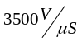 and the negative slew rate is 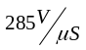. Although the negative simulated slew rate is very close to the calculated value of 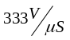, the simulated positive S.R is much better than the calculated value. Anyway, fig.8 shows that both positive and negative slew rate conform the desired values.
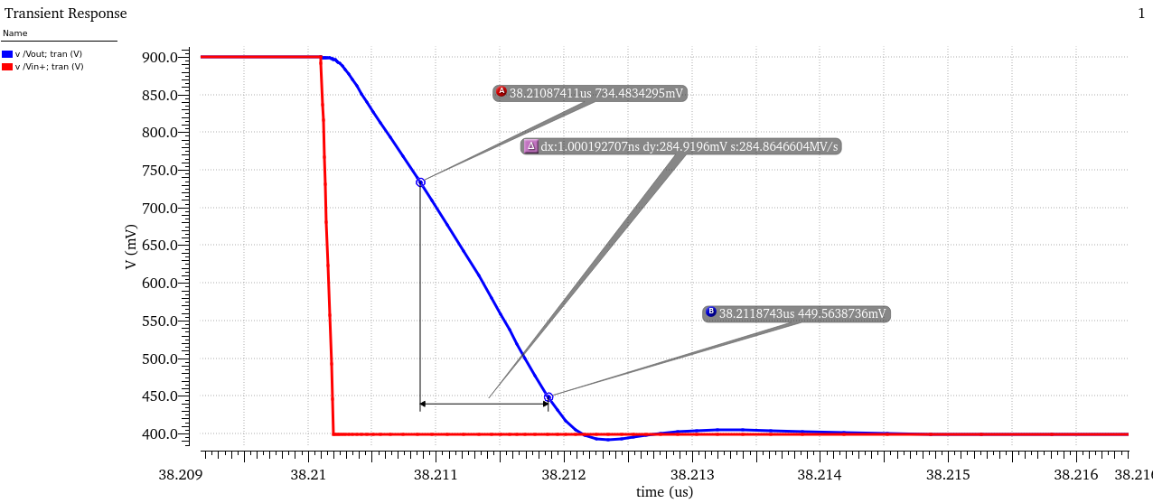
(a)
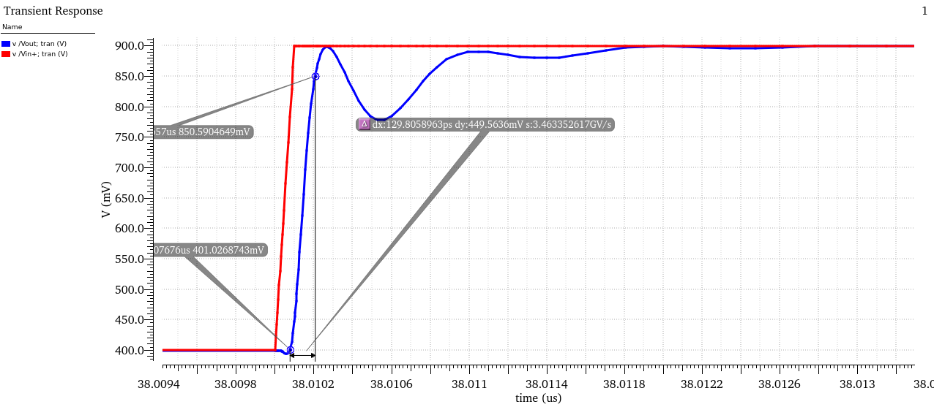
(b)
Fig.8. Slew Rate of the OTA, (a) negative S.R, (b) Positive S.R.

Neural Network Circuit Simulation Result
The schematic of the complete circuit of neural model using the proposed amplifier based is shown in fig.9. The circuit is based on primary circuit of fig.3 in which the amplifier and the current sources have been replaced by the transistor level circuit.
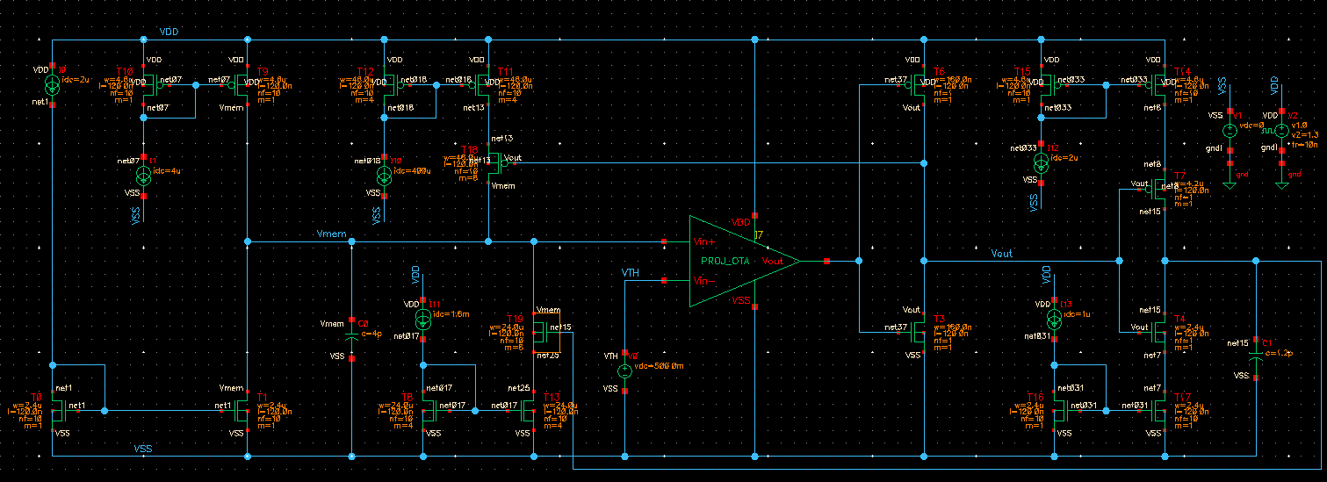
Fig.9. Schematic of the neural network model
The size of transistors and the value of current sources and capacitors are indicated in Fig. 9 as well. As we mentioned before by changing the value of capacitors, current sources and V_{TH} in Fig.9, it is possible to vary the period and the duty cycle of the expected signal.
According to the operation of the circuit in [2] we expect the circuit generates two different kinds of wave form at the Vmem node and the output node. In fig.10 the transient response of the circuit has been shown for the mentioned nodes.
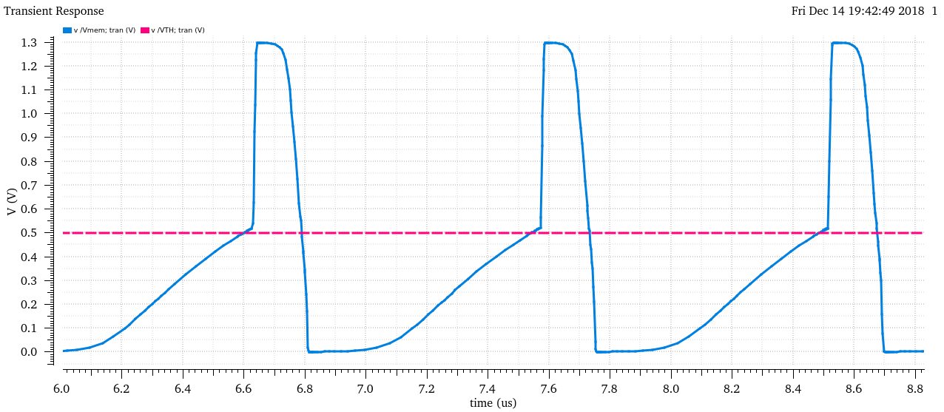
(a)
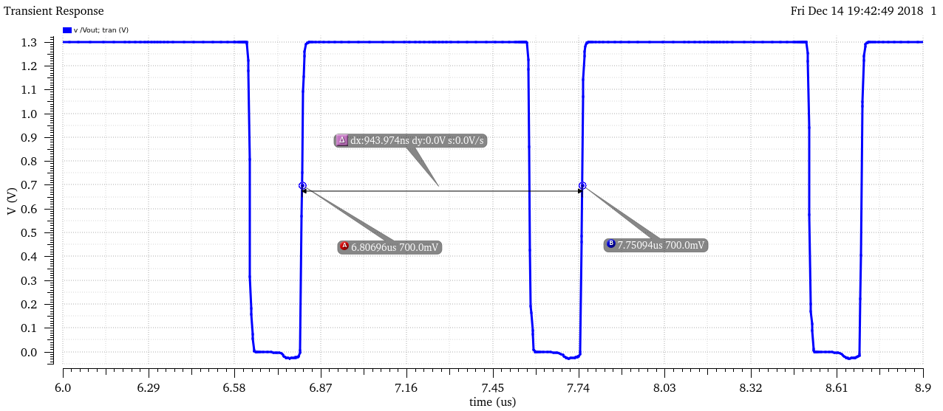
(b)
Fig.10. Transient response of Neural Network circuit. (a) Vmem (b) Vout

As expected, the circuit works like a A-stable circuit with a period about 1us. As it can be seen, both wave forms in fig.10 comply with the desired wave forms in [2].

Conclusion
In this article a high gain, high unity gain bandwidth OTA has been designed using TSMC 130nm CMOS technology. The steps of transistor level design to achieve the desired time domain and frequency response have been described and based on that the values of all component have been calculated. In Table. III the simulation results of the proposed circuit are summarized.

Table.III Simulation Result Summary

Parameter | Value
Technology | 130nm CMOS
VDD | 1.3 V
Current Consumption | 2.1 mA
DC Gain | 66 dB
UGBW | 800 MHz
Phase Margin | 52 Degree
Output Swing | 0.6 V
Input Common Mode Range | 0.5 V
CMRR | 75 dB
Slew Rate | 258 V/us

The values of parameter in Table.III, show that the proposed amplifier posses the desired design parameters with reasonable power consumption.

References

- B. Razavi “ Design of Analog CMOS Integrated Circuit” 2nd edition, MacGrawhill, 2011.
- A. Van. Schaik “ Basic Blocks for Electronic Spiking Neural Network”, Neural Network elsevier Journal, PP 614-628, January 2001.

